APPENDIX C (END-USER & ADMINISTRATOR MANUALS)

User guide for administrator

This manual is for administrator

User guide for end user

This manual is helpful for normal user who’s using our application for the first time.

Find a match

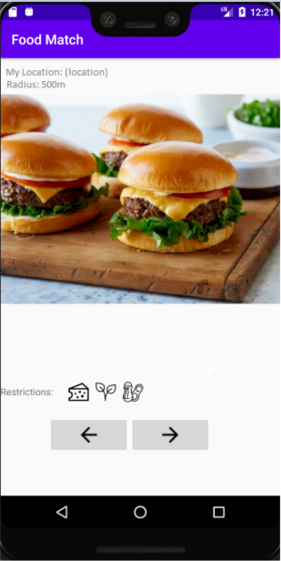

In order to start finding a match, navigate to match page by clicking ‘Home’ from menu at the top. Check if searching location and radius are set correctly. If not, go to ‘Change preference’ (page 61). One food picture will be shown on the screen at a time. The only information given about the food is restrictions including vegan, vegetarian, and allergy. If you want to see details about the food or information about the restaurant serving the food, swipe right on screen or click on right arrow (->) button. Then the restaurant information and their menu will be shown. If you want to pass on the displayed food and move to the next one, swipe left or click on left arrow (<-) button.

Get the matched restaurant’s information

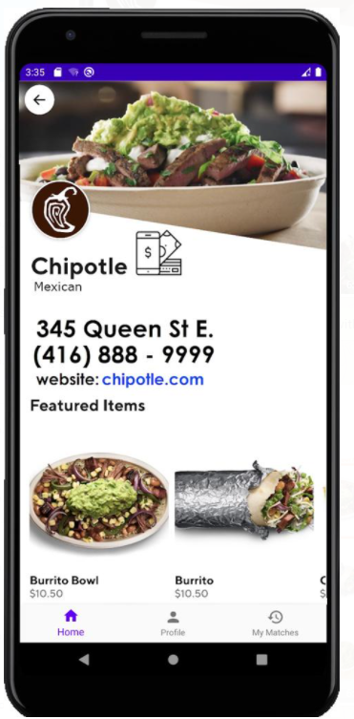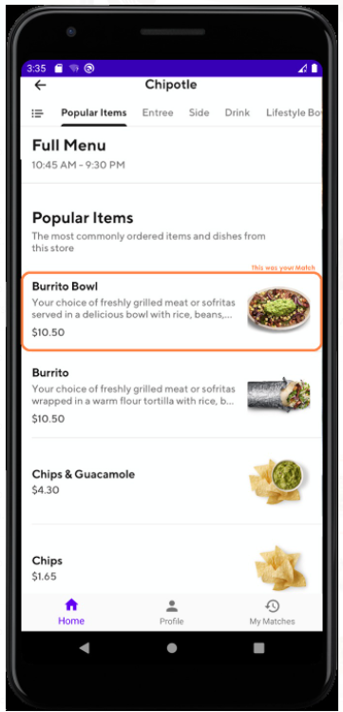

Once you swipe right on a food picture in finding match, you automatically see restaurant information page. The food you swiped on is highlighted in the menu. If you click on website URL, the website will open in your internet browser. If you click on phone number, your phone will dial to the restaurant.